Rotary Club of Castro Valley
Meeting Highlights - March 21, 2017

Lunch Speaker: Glenn Pomeroy, Chief Executive Officer of the California Earthquake Authority – Preparing for the Next Big Earthquake
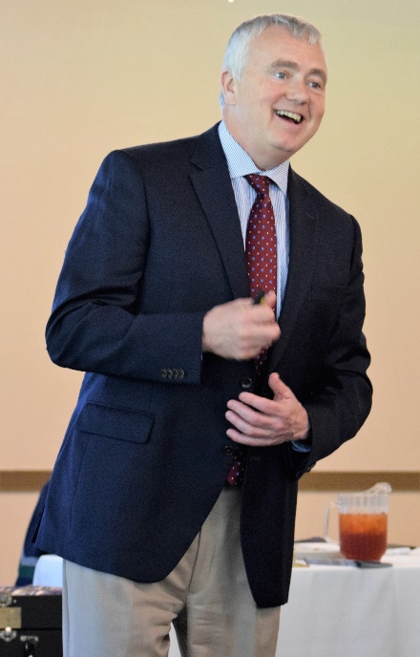
In 1996, the California Legislature created the California Earthquake Authority (CEA) – a not-for-profit, publicly managed, privately funded entity. Glenn Pomeroy has been the CEO of CEA—the largest earthquake insurance provider in the United States, and one of the largest in the world—since 2008. Glenn is originally from North Dakota, where he previously served his native state as a member of the North Dakota House of Representatives (he was first elected at age 22), county prosecutor, state Securities Commissioner and North Dakota Insurance Commissioner. While in that role he was selected by his peers from around the country to serve as President of the National Association of Insurance Commissioners.
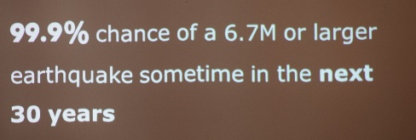
Glenn began his presentation by sharing the five facts, which every Bay Area resident must acknowledge:

- The risk of an earthquake happening in the Bay Area in our lifetime time is REAL. The probability of a 6.7M or higher earthquake in the Bay Area happening in the next 30 years is estimated to be 72%.
  - 90% of the homeowners in the Bay Area do not have earthquake insurance.
- Homeowners Insurance Policy in the Bay Area does not cover earthquake damage.
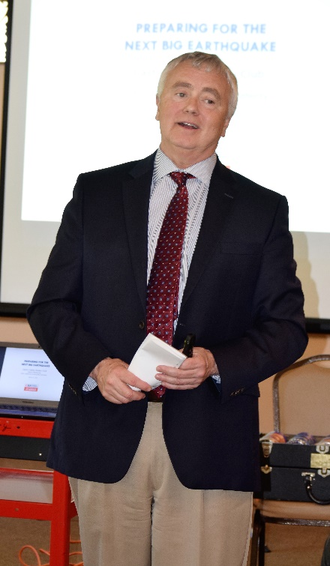
- The damage from a 1906 or 1984 type earthquake will be substantial. It is expected to be in the range of billions of dollars.
- Government funding will not be able to handle this damage to private residential property in the event of a major earthquake. Only about 937,000 people have earthquake damage insurance in California.
- CEA is a 20-year-old company which is a publicly managed and privately funded, not for profit organization that encourages California owners of homes, mobile home, condo units, and renters to reduce their risk of earthquake damage and loss through education, mitigation, and insurance. A CEA policy can help repair or rebuild your damaged home and replace your valuable personal belongings after a damaging quake.

CEA through various mechanisms currently has a claim paying capability of $14.1 billion. All homeowners should check out the benefits and cost of the earthquake insurance and perform their own cost-benefit analysis. Almost all insurance companies provide earthquake insurance through CEA.

Glenn also spent time dispelling myths about earthquake insurance and asking questions. He stress that Californians, especially in the Bay Area need earthquake insurance and that there are multiple policy options. Glenn suggested using the calculator on the CEA website to determine the best policy of individual needs. Additional information is available on the CEA website (https://www.earthquakeauthority.com/) and from local insurance agents like Todd Anglin, the monthly Speaker Chair who introduced Glenn.

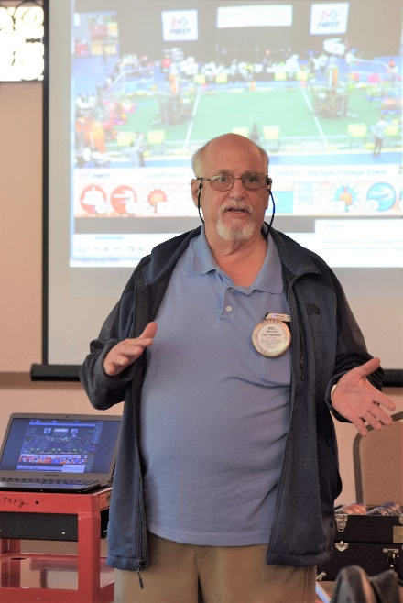
Robotics Competition
Castro Valley Rotarian Bill Nott is actively involved in the First Robotics Competition, which is an international competition for K-12 students. The competition was recently featured in the San Francisco Chronicle (http://www.sfgate.com/bayarea/article/Hundreds-of-students-in-SF-for-city-s-first-11011814.php). Bill showed a short video of the this year’s competition. The theme is SteamWorks — standing for science, technology, engineering, arts and math. Human drivers remotely controlled their robots to zoom around the field to gain points by collecting yellow Wiffle balls (representing fuel) that they shot into a target (the steam boiler), as well as gears that they delivered to towers (the airship), where human pilots put them in place. If you ever have a chance to attend a Robotics Competition, don’t miss it.

Breathing for Life Project
President Carol reported that everyone who donated to the Breathing for Life Project will be acknowledged with a thank you letter from the Rotary Club of Castro Valley. District 5170 will send letters for donations of $250 or more. If you have any questions, please contact President Carol.

Upcoming Events

March 28: Lunch Speakers - Becky Passche and Antonia Mambelli, Woodroe Woods School
April 4: Lunch Speaker – TBA
April 10: Board of Directors meeting – 6:00 p.m. at the Chamber of Commerce
April 13: District 5170 Assembly at the Indian Cultural Center in Milpitas at 5:00-9:00 p.m.
All 2017-2018 board members and committee chairs are strongly encouraged to attend. The Club pays the registration. President-Elect Jim Negri has sent out information. Please contact him with questions. Attending a District 5170 event is a requirement to earn a Blue Badge.

